JDBC stands for Java Database connectivity’s. It is a software layer that allows developers to write real client-server projects in Java. JDBC was designed to be a very compact, simple interface focusing on the execution of raw SQL statements and retrieving the results. The components of JDBC are Application, Driver manager and Driver.

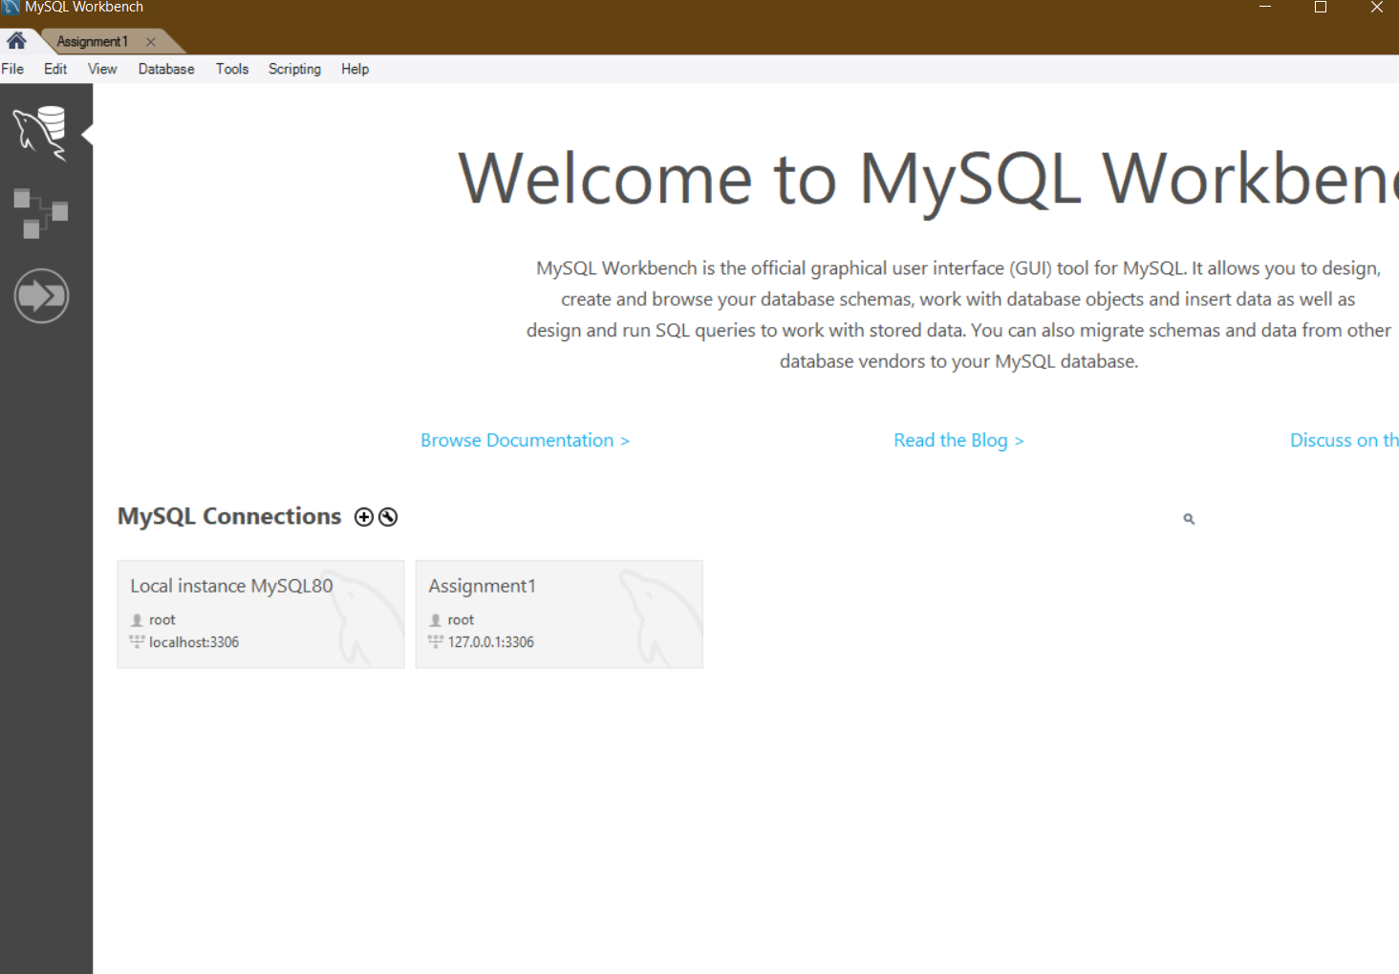

1. Assignment1 has been added into connection

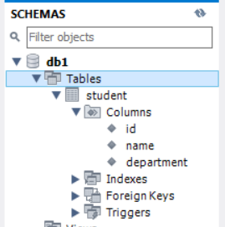

1. New schema(db1) has been created, and table with necessaries information has been added

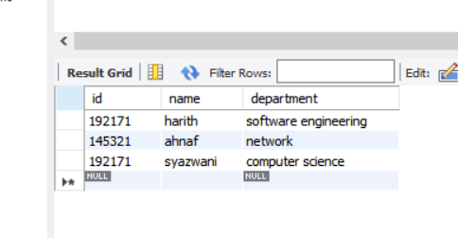

1. Have added some records in the table

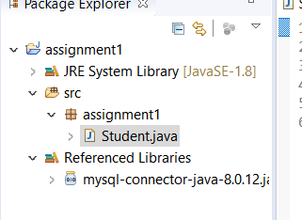

1. Java project has been created; MySQL connector has been added; package file has been created and class named ‘student’ has been created under src folder